

**(15) Cuerden Strategic site Road infrastructure** – Quarter 4 has focussed on securing the necessary LCC approvals to progress the project following the extensive options review process. Works next quarter will now focus on off-site highways design works around the M65 terminus and slip road.

**(4) Grimsargh Green** – The scheme to deliver a football pitch was programmed to complete in Q4 but further guidance received from the football Association recommends carrying out the work between April and September in order to maximise the benefits from the scheme.

**(14) Eastway link road**

This scheme started on site on 29th April with enabling works. The build programme is expected to complete by 26th November 2019 with the D'Urton lane section completed on 2nd September.

**(1 )Preston Western Distributor (PWD) and East West Link Road (EWLR)**

Lancashire County Council cabinet formally agreed to support the commitment made by the City Deal Executive to fund the local contribution of the North West Roads programme subject to the full approval of the final business case by the LEP and Dft to release the government funding – Submission of full business case for approval of release of funds by the LEP is on 26th June 2019 followed by the DFT within 8 weeks. The decision notice for the PWD CPO has now been confirmed by the Secretary of state.

**(5)Cottam to Preston cycle improvements**

The scheme is now progressing without any issues – a design has now been approved and delivery plan is being developed.

**(3) Hutton/Higher Penwortham/City Centre corridor – works related to planning condition**

Works associated with Penwortham bypass planning permission include traffic calming and measures to encourage road users onto the bypass. Concept designs for the Penwortham Triangle which is the starting point of the scheme were considered by IDSG in March. Consultation on the wider corridor works took place in October and a report of findings is being considered.

**(2) Penwortham Bypass**

Progress remains positive and on programme. Work has scaled down as the wait is underway for the establishment of the playing field. Preparatory work has commenced on the A59 at Howick Cross – this is principally laying of traffic signals, street lighting and statutory undertakers ducts.

**(13) South Ribble Western Distributor - A582 Dualling**

Work continues on the detailed design and planning application development. A project board has been established to oversee this scheme development. Design and submission of planning application anticipated in January 2020. SOBC being prepared for submission to Transport for the North for inclusion in the schemes put forward for funding under Major Road Network proposals.

**Other pipeline projects**

**(16) Moss Side Test Track:** The Planning Application is likely to be presented to a special Planning Committee in September 2019. There are however still outstanding issues that work is taking place to try and resolve, in relation to off-site highway works; viability; the proposed school site; inter-relationship between the housing and industrial parts of the site ; and also ecological provision.

**(17) Pickering’s Farm link Road:** The consultation period on the draft Master Plan is now complete. Dates are not set but it is understood the Masterplan will be submitted in the near future followed by an Outline planning application. A meeting is taking place with the applicants and their agent on 3rd July to seek clarity with respect to the timings above.

**Green** – no issues - project is on target, within budget allocations - timescales and to an appropriate quality standard. Some risks have been identified (recorded on the risk register) but these are low and can be managed.

**Amber** – There are some issues that may affect programme, delivery, cost and/or quality but they are currently being managed and mitigation measures are in place - Project will be delivered in budget - Programme manager is satisfied that key stakeholders are aware of delay. PM has accepted that political/logistical impact will need to be managed. Mitigation measures being implemented.

**Red** – Issues have arisen but at this point appropriate mitigation measures have not been agreed or implemented. Project delivery timescales have slipped and financial forecasts indicates overspend. Programme manager/stakeholders are not yet aware of delay or have not accepted that the political/logistical impact on project delivery will need to be managed. Mitigation measures have not yet been implemented. When agreed they should be outlined in issues log with the appropriate issue owner.

**City Deal Infrastructure Delivery – Year 5 - Quarter 4 – (January – March 2019 performance update)**

**Appendix 4**

**(7) Guild Wheel Bluebell Way**  this scheme continues to face funding uncertainty although progress has been made on sourcing additional funding via a Deed of Variation to a section 106 agreement although this has yet to be confirmed. If funding is secured the scheme will be able to proceed but delivery will slip by 6-9 months from the original predicted start of site in year 6, quarter 2.

**(6) Broughton/Fulwood (corridor north of M55)**

Main village centre public realm upgrade work, including Broughton crossroads commenced during January 2019. Project involves wider footways, narrower carriageways with extensive use of natural stone kerbs and paving material. Work is expected to complete by the end of July 2019.

**(12) Bamber Bridge – Town Centre Improvements** The footway improvements are now complete – the final section of road re-surfacing is now programmed for October 2019.

**(10) East Cliff Cycle Link and Bridge**

A £200,000K allocation from city Deal towards the bridge works has been made. The cycle link design work will now be progressed and a delivery plan prepared.

**(8) Fishergate Phase 3 (including Western apron)** Planning permission received for Western Apron public realm and contractors started on site on 18 March 2019. Construction is proposed in 3 phases and due to complete in December 2019. Programme dates agreed for the remaining fishergate 3 street works (mainly Tithebarn Street) and work will commence on site 7 May 2019 to finish by mid-November.

17

16

11

7

6

15

14

13

12

10

9

8

3

5

4

2

1

**(11) Guild Wheel Watery Lane** Good progress has been made on this scheme. Work commenced on site on 4th march 2019 and at the time of reporting at the end of March a substantial length of side channelling to the road and other drainage works had been undertaken. It is anticipated that substantial completion of the works will now be by the end of May 2019. Scheme currently reporting amber due to delay from original programme.

**(9) New Hall Lane Local Centre** The majority of this scheme is now complete, the final section of road re-surfacing is now programmed for October 2019.

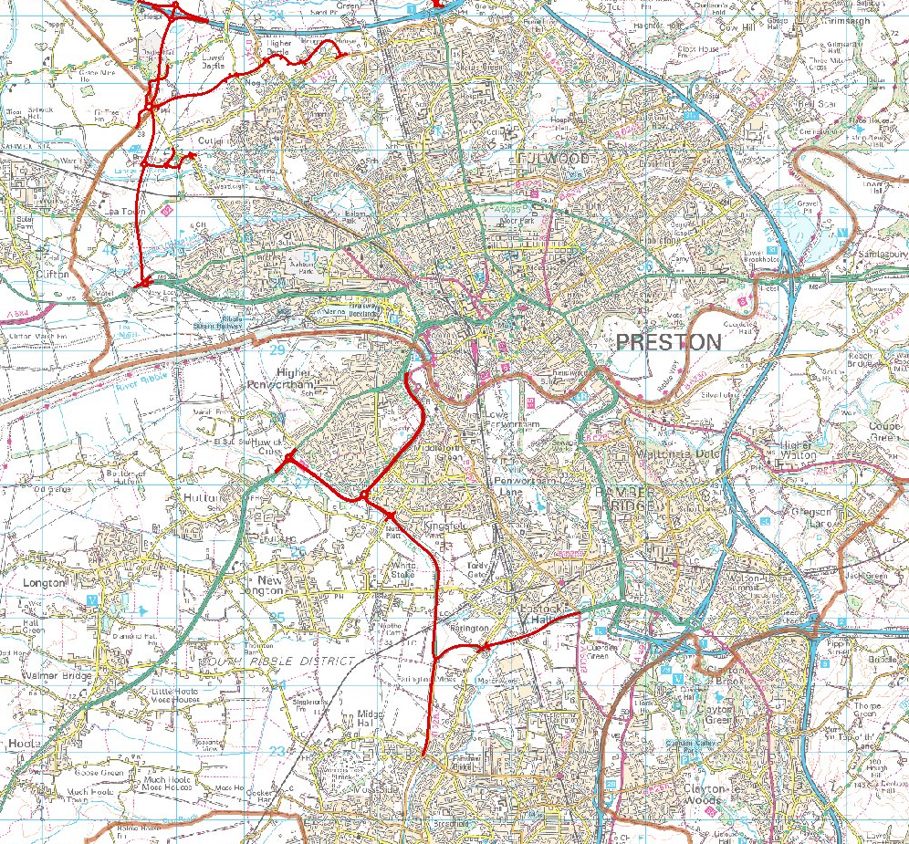

**Appendix 'A'**